Citizenship

Table as per design

ERD: Citizenship and Gender

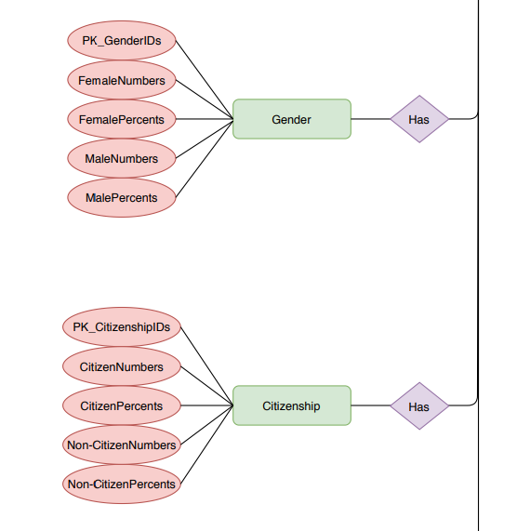

* + Columns (checked, all good)

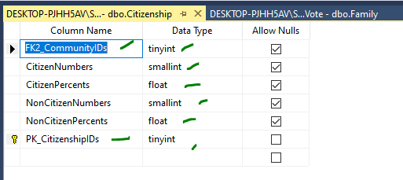

Rows retrieved 131 rows

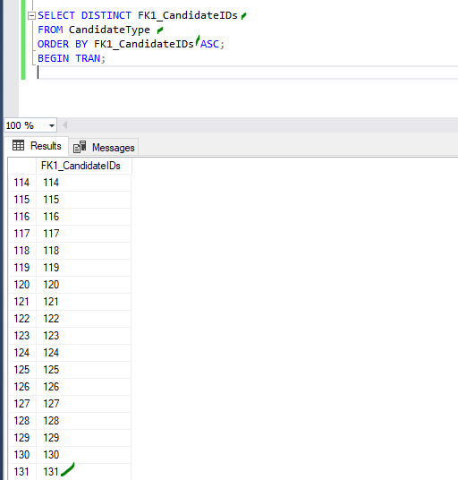

Data Manipulation

Primary Key - Explicit Insert for Identity Column

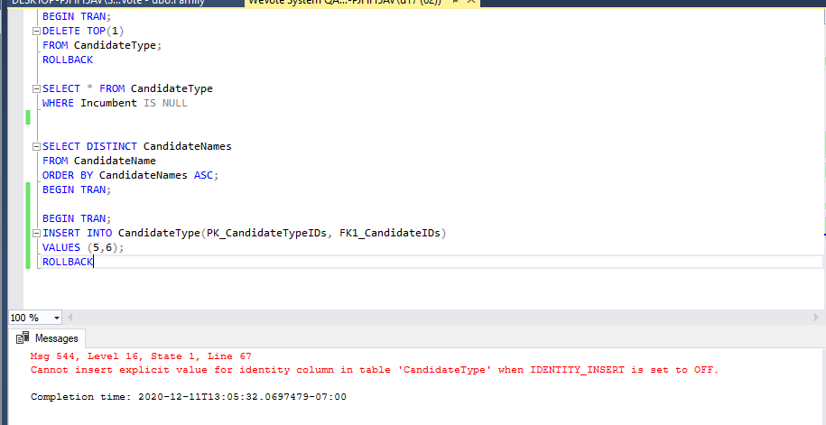

Primary Key – Update

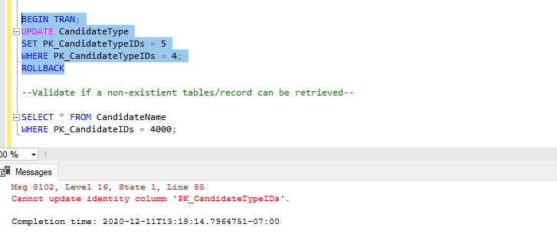

Primary Key – query non existent ID

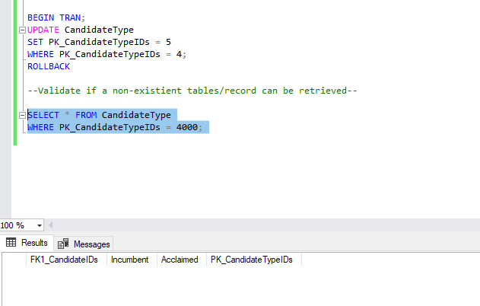

Primary Key not related to other and with Foreign Key

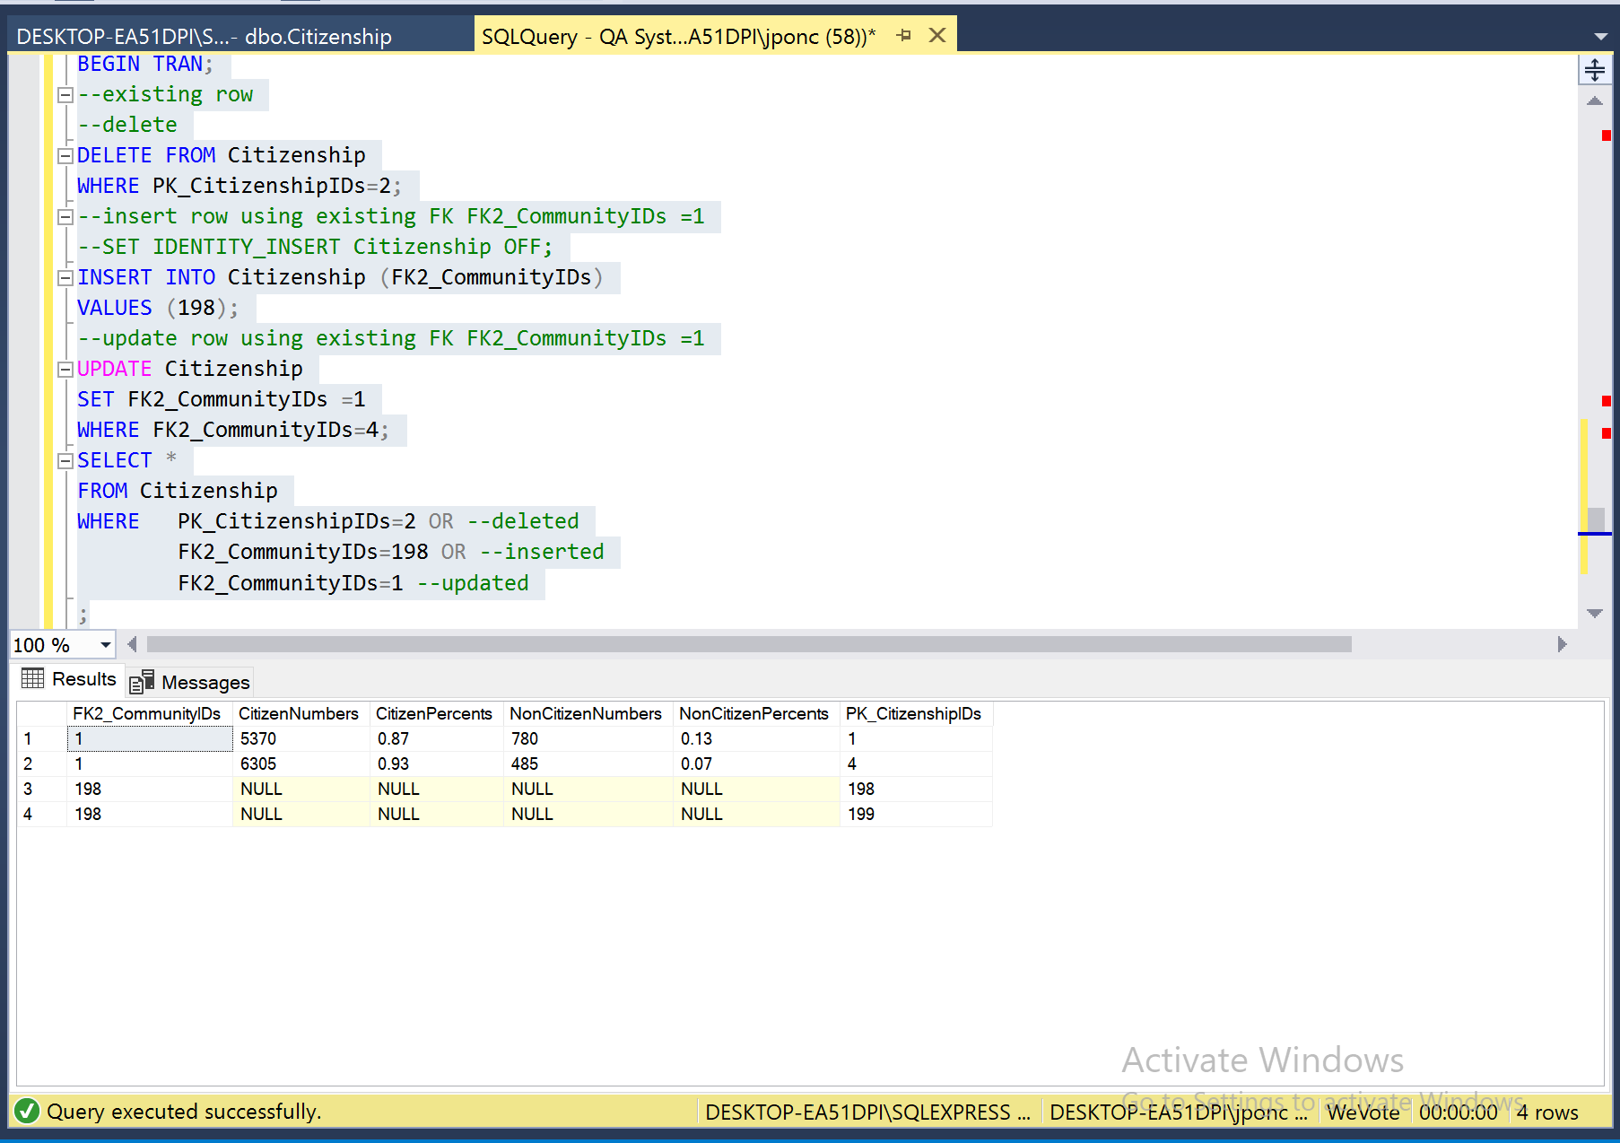

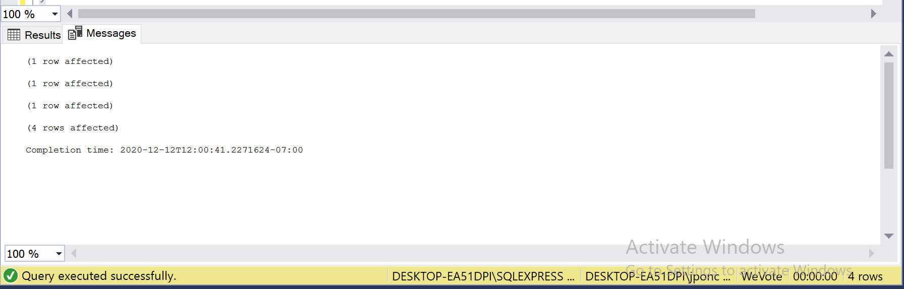

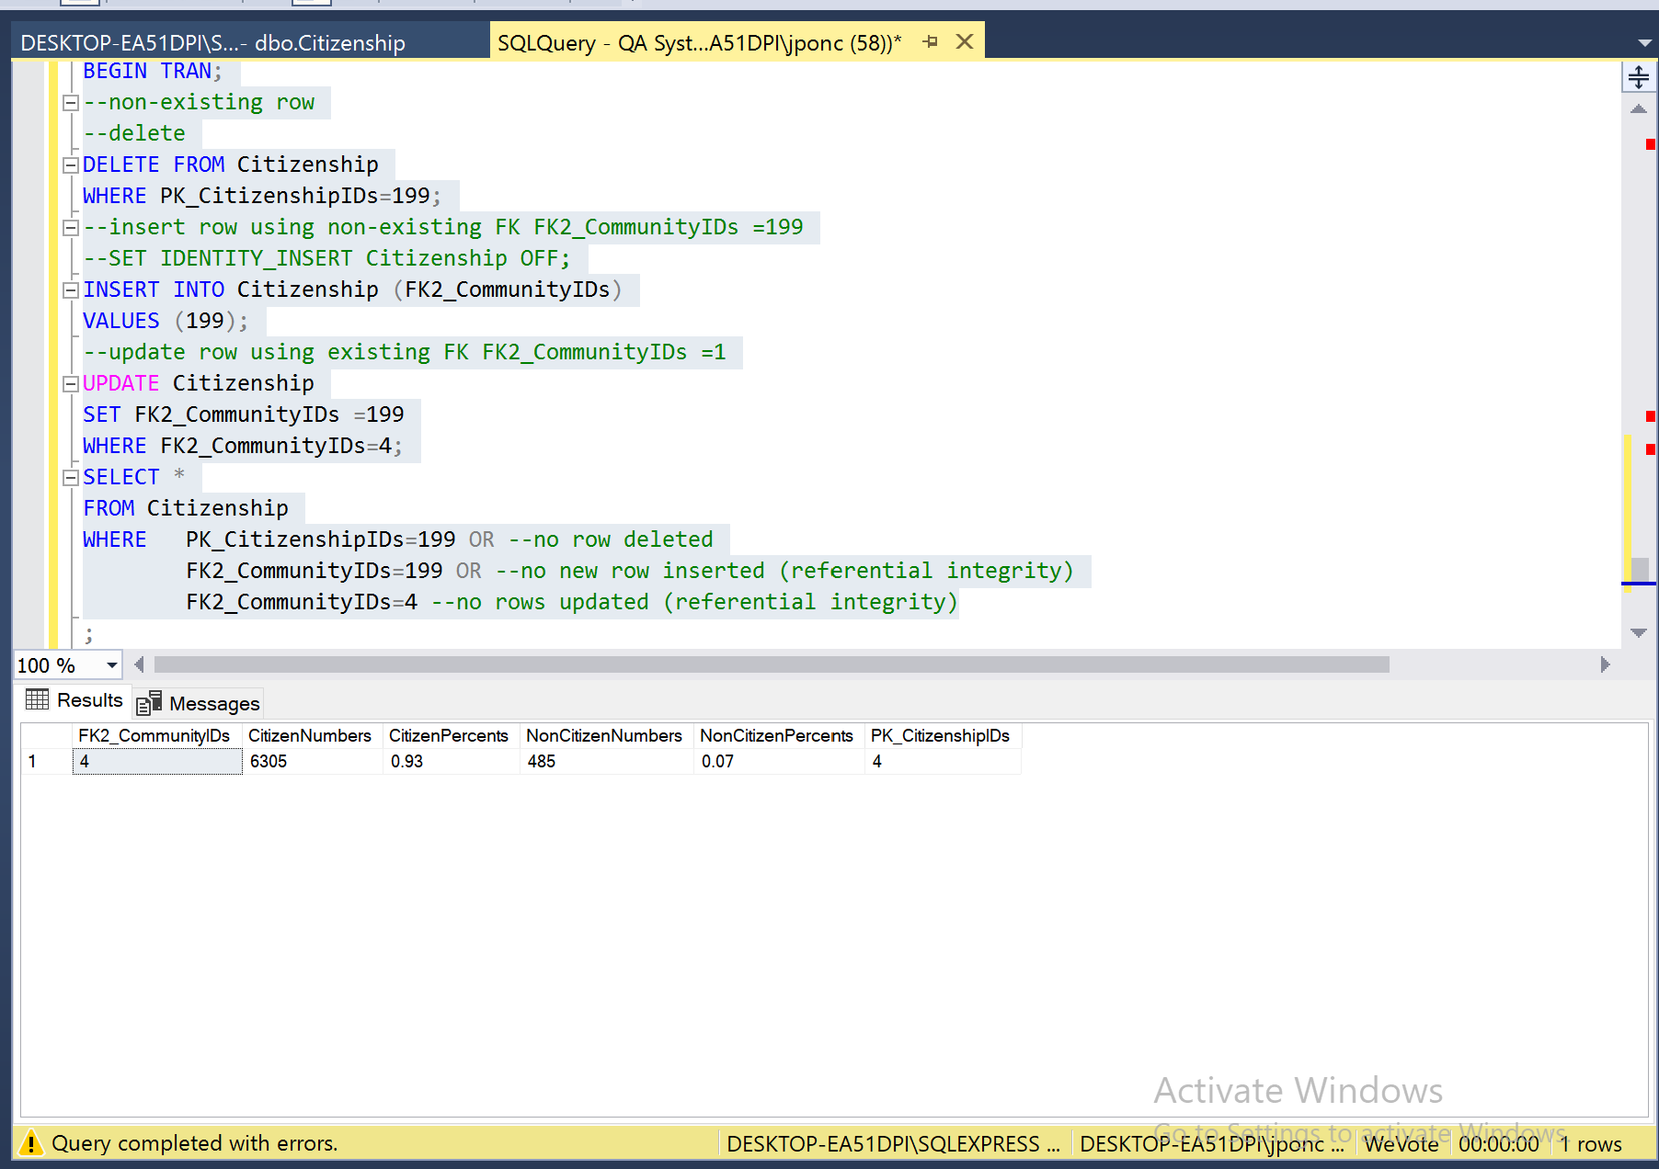

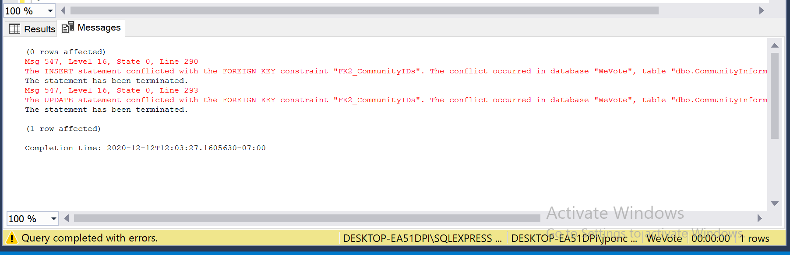

**Dec. 21, 2020**

1. Citizenship:

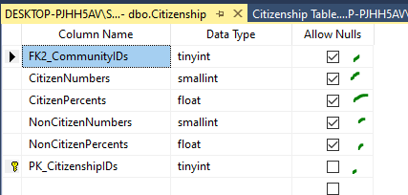

* Validate if records can be inserted into current PK--

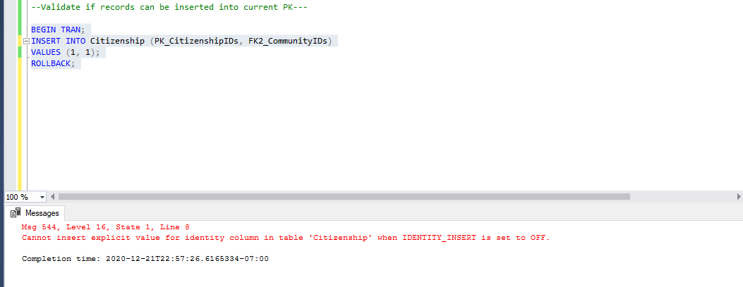

* + Validate if records can be updated using current PK—

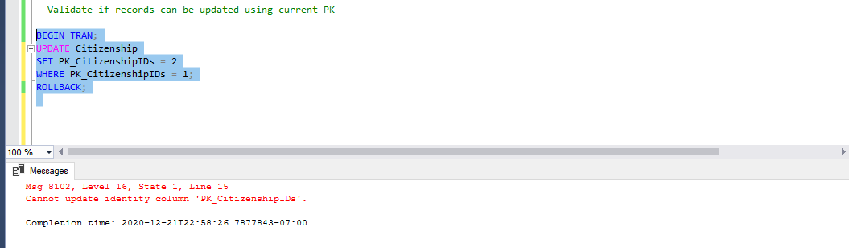

* + Validate if non-existent record can be retrieved

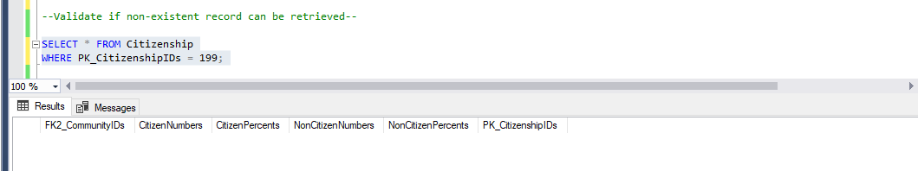

* + Validate if Primary Key not related to other and with Foreign Key

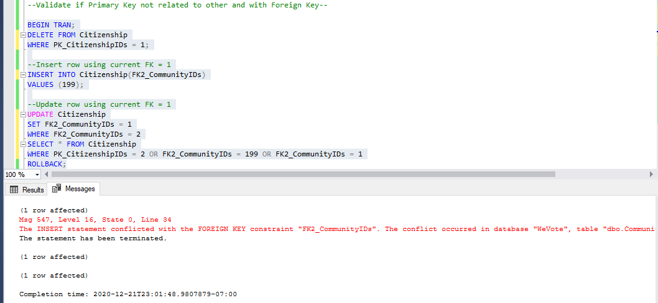

* + Validate if PK not Null constraint

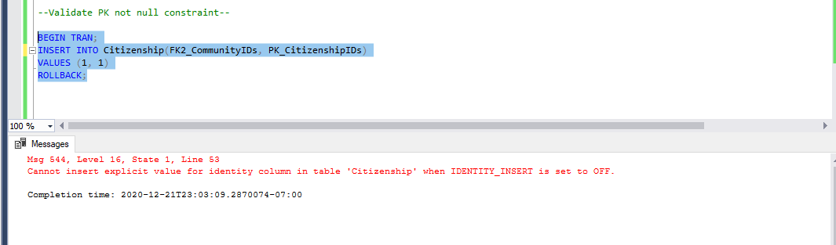

* + Validate if a null PK can be updated

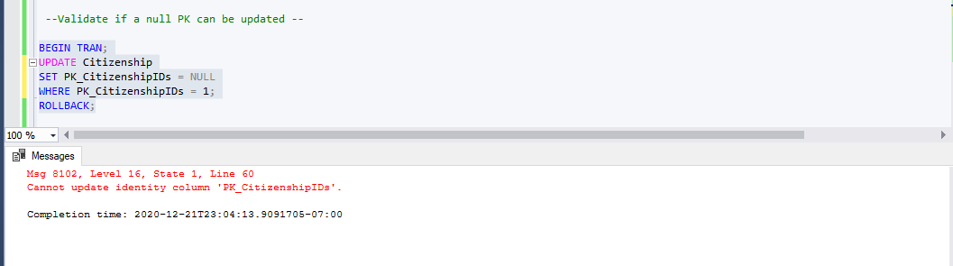

* + Validate CandidateName > NOT NULL constraint>When: Undefined Candidate Name >is added >Then:Insert nor update is not allowed

